**Marvel’s Spider-Man 2 Debug Menu**Basic guideline on its usage and possibilities



Marvel’s Spider-Man 2 Key Art

**Documented by Cranch the Wolf for SM2 PC Brazil**  
Insomniac Engine 2023-2024

**How to access Debug Menu?**There’s 2 variations of exact same menu you can get access to:

1. **Debug Menu – ImGui**First method we’re going to look in to can be considered some kind of developer console you can find in many other games. In order to access it, we need to hover our mouse cursor to the upper-left corner of the screen (small window with “ImGui” text on it will suddenly appear).  
   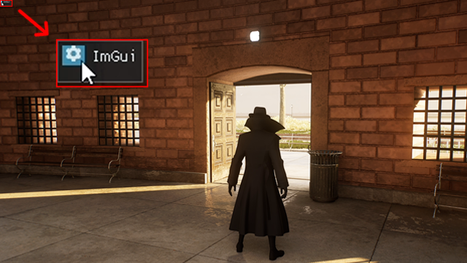  
     
     
   Now we’re one step closer to Debug Menu, next thing we need to do is to press button with a gear on it. “Debug Menus” sub-menu is the one containing Debug Menu, the one we’ve been looking for.   
     
     
     
   Menu can be controlled with mouse cursor and **Left Mouse Button.** Considering you’ve done everything you wanted, here’s how to close ImGui:  
   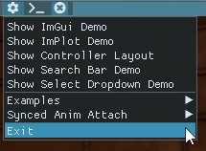
2. **Debug Menu – Menu**This method can be found more convenient to work with for many players, but it requires some adjustments to be done first. Starting up our Launcher, we need to proceed to the settings menu.  
   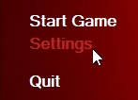  
     
     
   On “Main” settings tab, search for “Debug Mode” option and set it to either “Partial” or “Full”, so we can have access to Debug Menu.  
   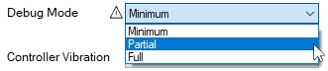  
     
     
   Once we successfully turned on debugging for our game, we can launch it up and press “ESC” on keyboard to bring up the menu.  
   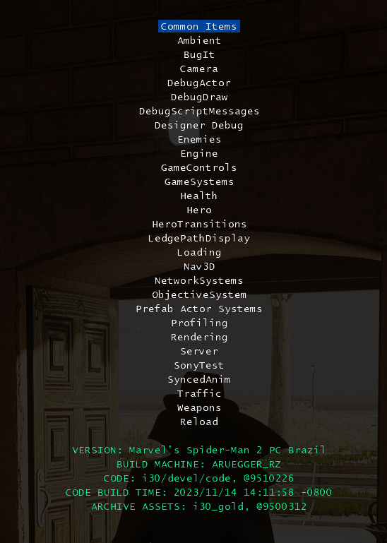  
     
   Menu can be controlled with:   
   - **arrow up / arrow down** to move between sub-menus and options;   
   - **ENTER** to open up selected sub-menu or interact with option;   
   - **BACKSPACE** to return to previous sub-menu / exit Debug Menu;  
   - **arrow left / arrow right** to choose between values for selected option;  
   - **TAB** to add / remove selected option to the / from the “Common Items” sub-menu.

**There are 3 types of options:**

1. **Option = Value**  
   The most common kind of options you will find all around the sub-menus, it consists of parameter name and what it currently equals. Depending on option, value can be either selected from pre-determined by developer values or set in range of numbers (such as 0 – 2048).  
   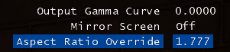
2. **Option = Value (Read only)**Sometimes you will face options following the same logic we’ve described earlier, but with one major difference – you cannot edit them. Such options appear green in Debug Menu and their main purpose is to report various facts about game systems to the developer (such as “Is it raining right now? – No, it’s not”)  
   
3. **Perform action**This one differs depending on context it’s been found in. Let’s look in to Temporal AA (TAA) and upscaling we can use with it.  
     
     
   In this scenario, we have 2 different options one of which determines value and second one performs action of applying changes we’ve made.  
     
   Our current resolution is equal to 1.0000 (100%) and we want to shrink it down to 0.6000 (60%) to free up some GPU resources. Just editing “Temporal AA Upscale Scale” value will not affect our game right until we hit “Apply Temporal AA Upscale Scale” option.  
   

**How to bring up Debug Menu with controller?**L1 + Start (ImGui) / L1 + Share + Start (Menu) **How to skip current mission?**From the very root of Debug Menu, follow next path:  
“Reload 🡪 Complete Primary Objective (Preserve Progression)”   
  
**How to disable pedestrians?**From the very root of Debug Menu, follow next path:  
“Traffic 🡪 Pedestrians 🡪 Enable Pedestrians”  
  
**How to gain character level?**From the very root of Debug Menu, follow next path:  
“Game Systems 🡪 Progression 🡪 Level Up Once”  
  
**How to unlock everything / hack progression?**From the very root of Debug Menu, follow next path:  
“Game Systems 🡪 Progression 🡪 UnlockAll”  
  
**How to set time of day?**From the very root of Debug Menu, follow next path:  
“Designer Debug 🡪 Lighting Mode 🡪 Set Lighting Mode”  
  
**How to enable God Mode?**From the very root of Debug Menu, follow next path:  
“Health 🡪 Heroes do not take any damage”  
  
**How to play as Venom?**  
From the very root of Debug Menu, follow next path:  
“Health 🡪 Character Selection 🡪 Select Character”OR  
Start your game with “Debug Mode” set to “Full”, there will be floating menu with all the characters you can choose from.   
  
…